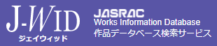
※The JASRAC work code shall be confirmed via the JASRAC Works Database Search Service (“J-WID”).
※To add an additional row, position the cursor at the lower left corner of the table and select the “＋” symbol.
※ In the case of works for which the copyright protection term has expired, the designation “PD” shall be entered.
Where the work code cannot be identified, the designation “N/A” shall be entered.

No | Song Title | Lyricist | Composer | JASRAC Work Code | ISWC Code | Original Artist
(Example) | God knows... | Aki Hata | Satoru Kosaki | 133-1209-0 | T-909.725.413-2 | Haruhi Suzumiya (CV: Aya Hirano)
1
2
3
4
5
6
7
8
9
10

